# GitHub: https://github.com/thetalhamirza/ictlabs

# Q1.

Code:

HTML:

<!DOCTYPE html>

<head>

    <title>Color Change</title>

    <script>

    let i = 1;

    const color = ["red", "blue", "green", "yellow", "purple", "orange"];

    function colorChange()  {

        document.body.style.backgroundColor = color[i];

        i++;

        if (i == 6) { i = 1 }

    }

    </script>

</head>

<body>

    <button type="button" onclick="colorChange()">Change!</button>

</body>

</html>

Screenshots:

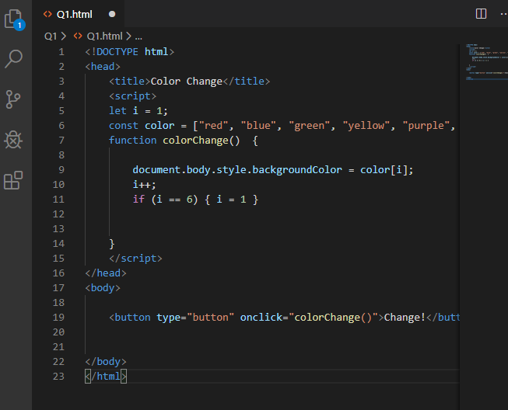

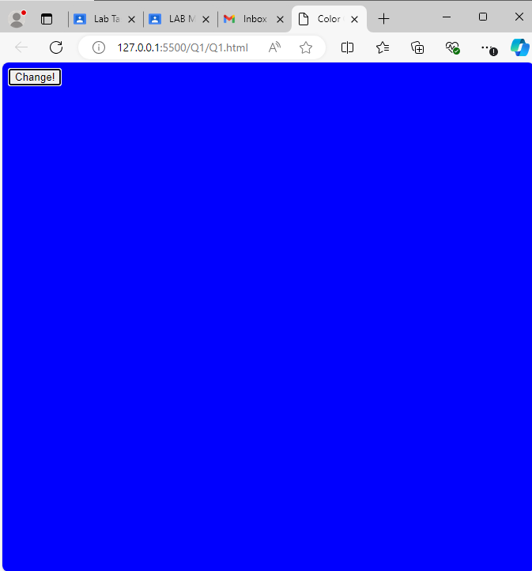

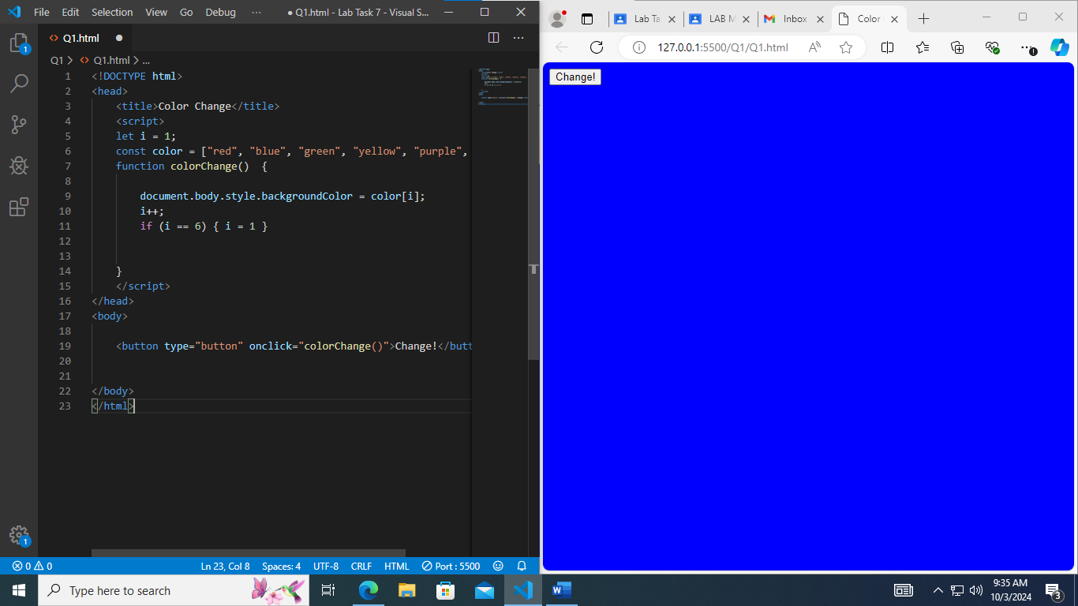

# Q2.

Code:

HTML:

<!DOCTYPE html>

<head>

    <title>ALERT</title>

    <style>

    body    {

        background-color: aliceblue;

    }

    .checkbutton {

        padding: 200px;

        align-items: center;

        box-shadow: 0px 2px 10px rgba(0,0,0,0.1);

    }

    </style>

</head>

<body>

    <script>

    function alertMessage()    {

        alert("YOUR COMPUTER HAS A VIRUS")

    }

    </script>

    <button onclick="alertMessage()" class="checkbutton">Check Ma PC</button>

</body>

</html>

Screenshots:

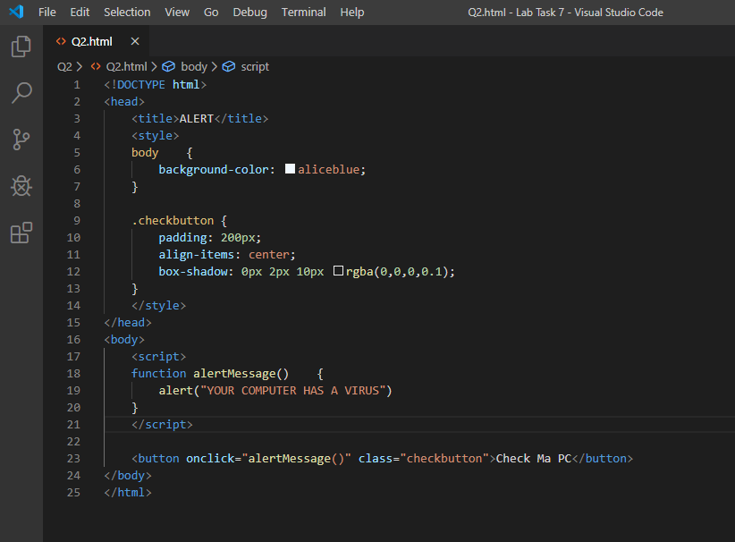

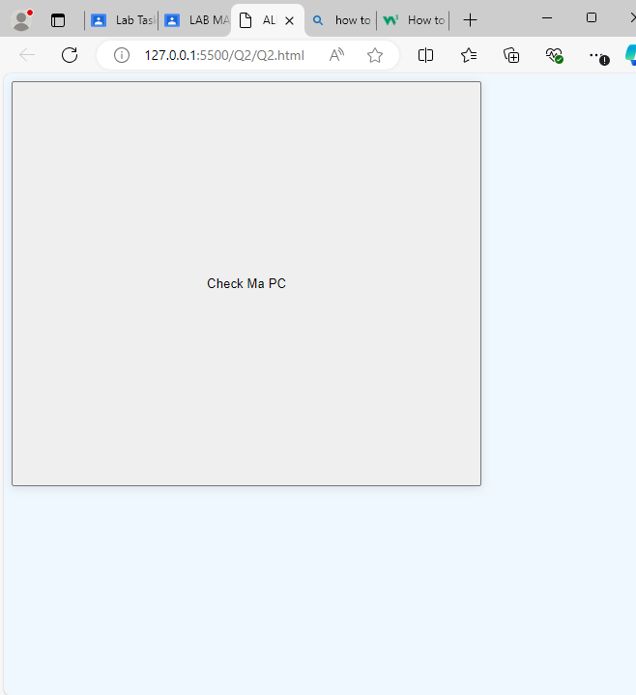

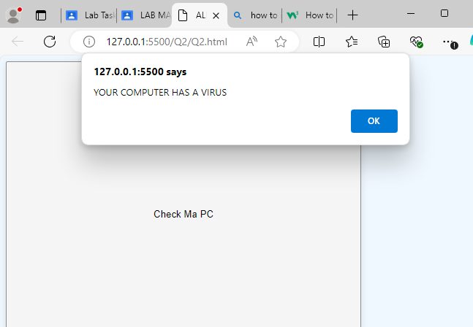

# Q3.

Code:

<!DOCTYPE html>

<head>

    <title>Calculator</title>

</head>

<body>

    <input id="numA">

    <input id="numB">

    <script>

    function addNums()  {

        document.getElementById("answer").innerHTML = parseFloat(document.getElementById("numA").value) + parseFloat(document.getElementById("numB").value)

    }

    </script>

    <button type="button" onclick="addNums()">ADD!</button>

    <p>The answer is: </p>

    <p id="answer">0</p>

</body>

</html>

Screenshots:

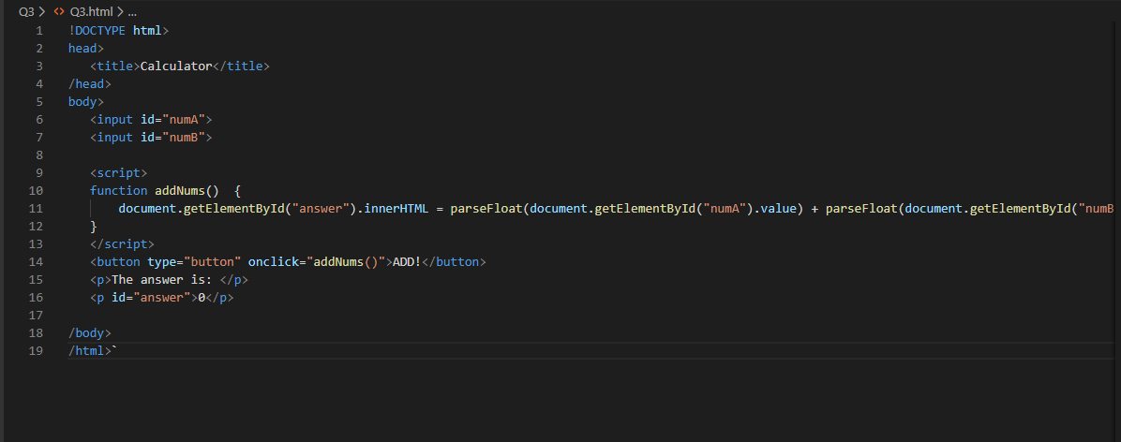

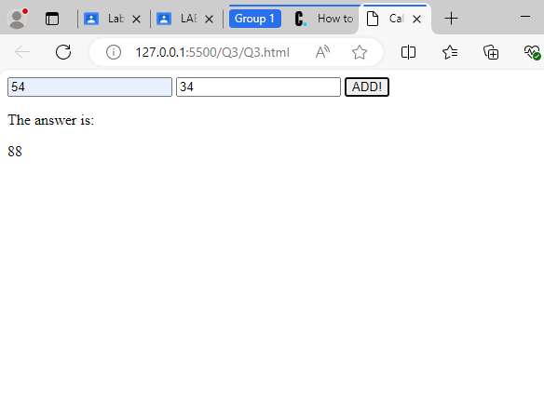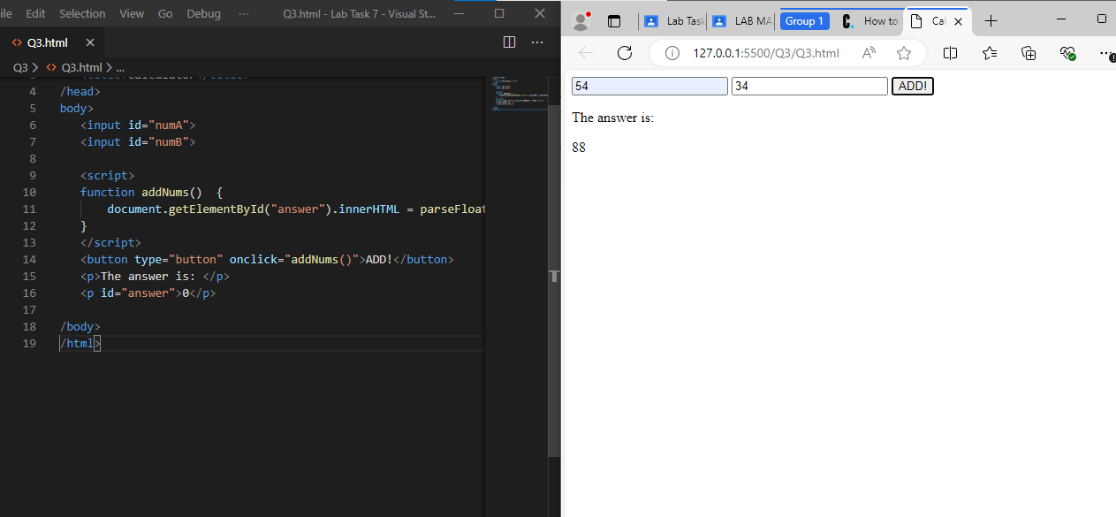

# Q4.

Code:

<!DOCTYPE html>

<head>

<title>Click Counter</title>

</head>

<body>

<script>

let count = 0

function countadd() {

count++;

document.getElementById("counter").textContent = count;

}

</script>

<p id="counter">0</p>

<button type="button" onclick="countadd()">MORE</button>

</body>

</html>

Screenshots:

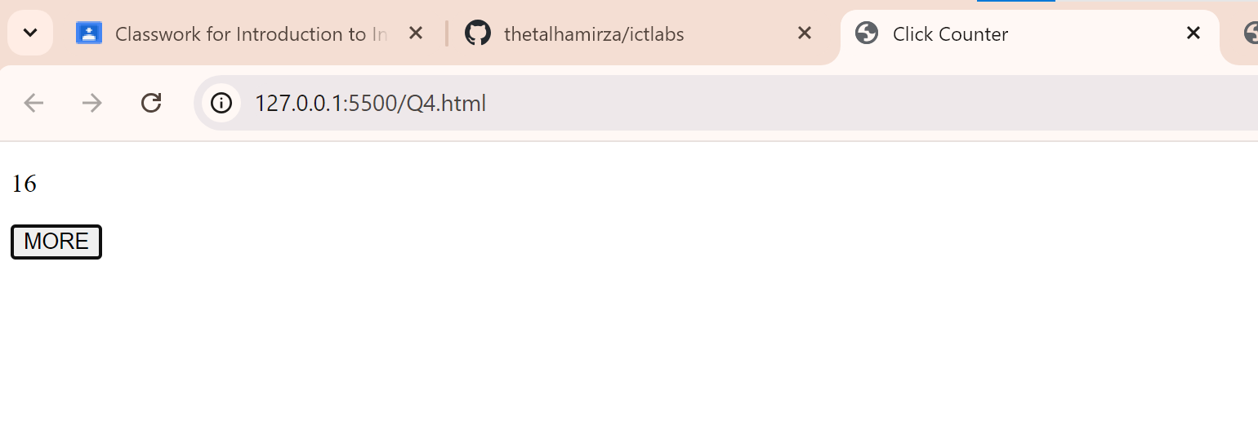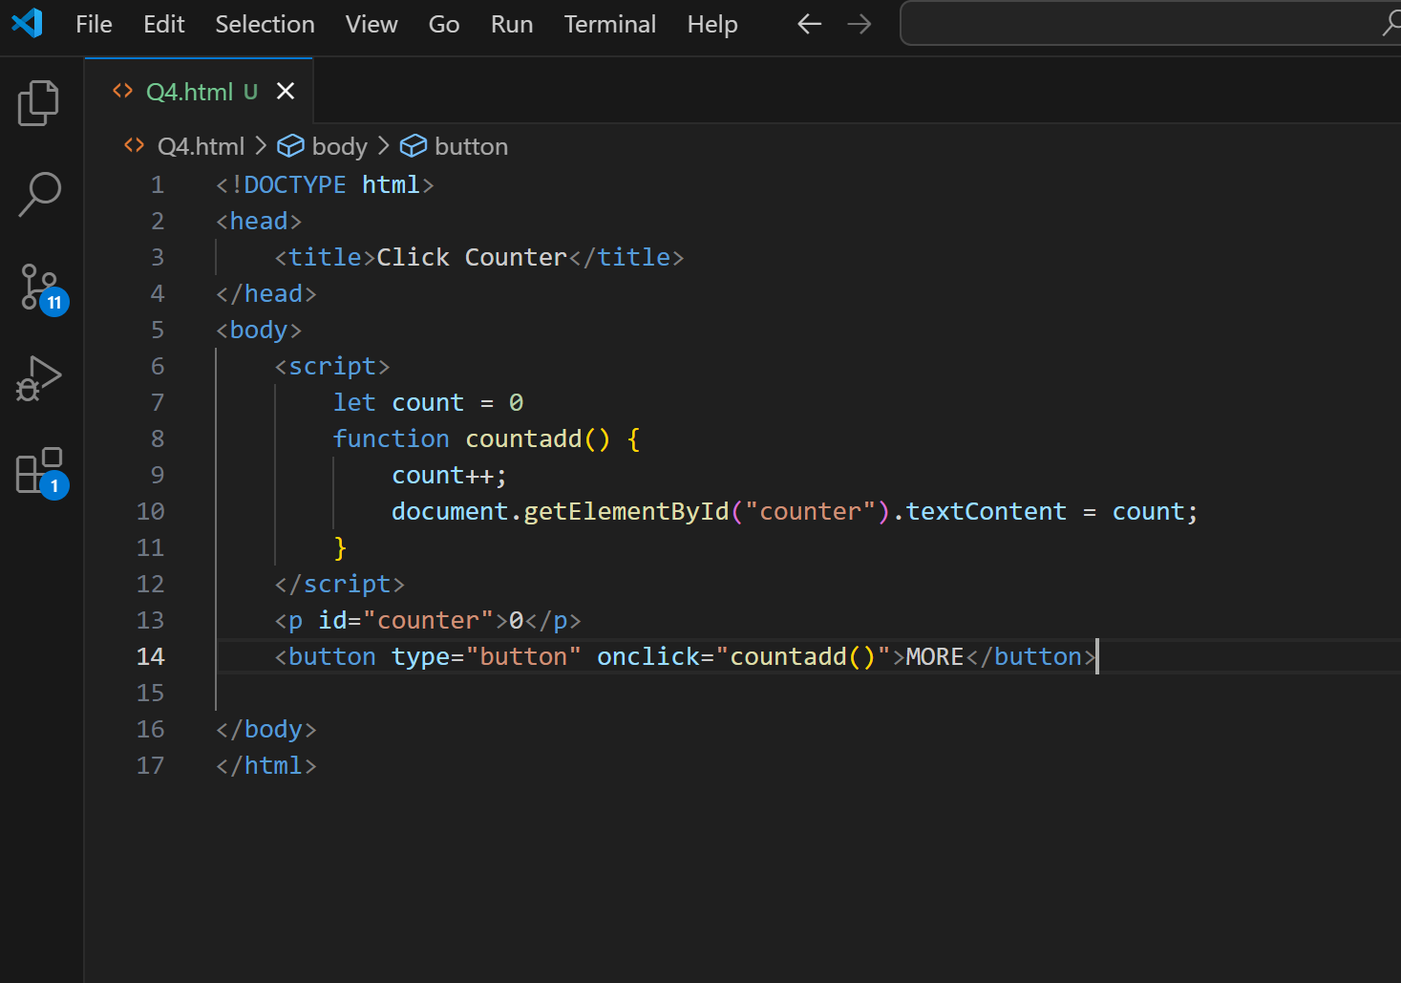

# Q6.

Code:

<!DOCTYPE html>

<head>

<title>Title Color Changinator</title>

</head>

<body>

<h1 id="title">LETS GOO</h1>

<script>

let i = 0

const color = ["red", "green", "blue"]

function changeColor() {

document.getElementById("title").style.color = color[i]

i++;

if (i == 3) {i = 0}

}

</script>

<button onclick="changeColor()">CHANGE!</button>

</body>

</html>

Screenshots:

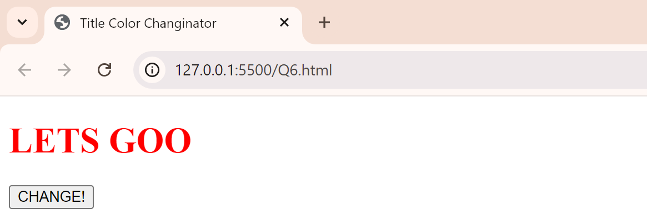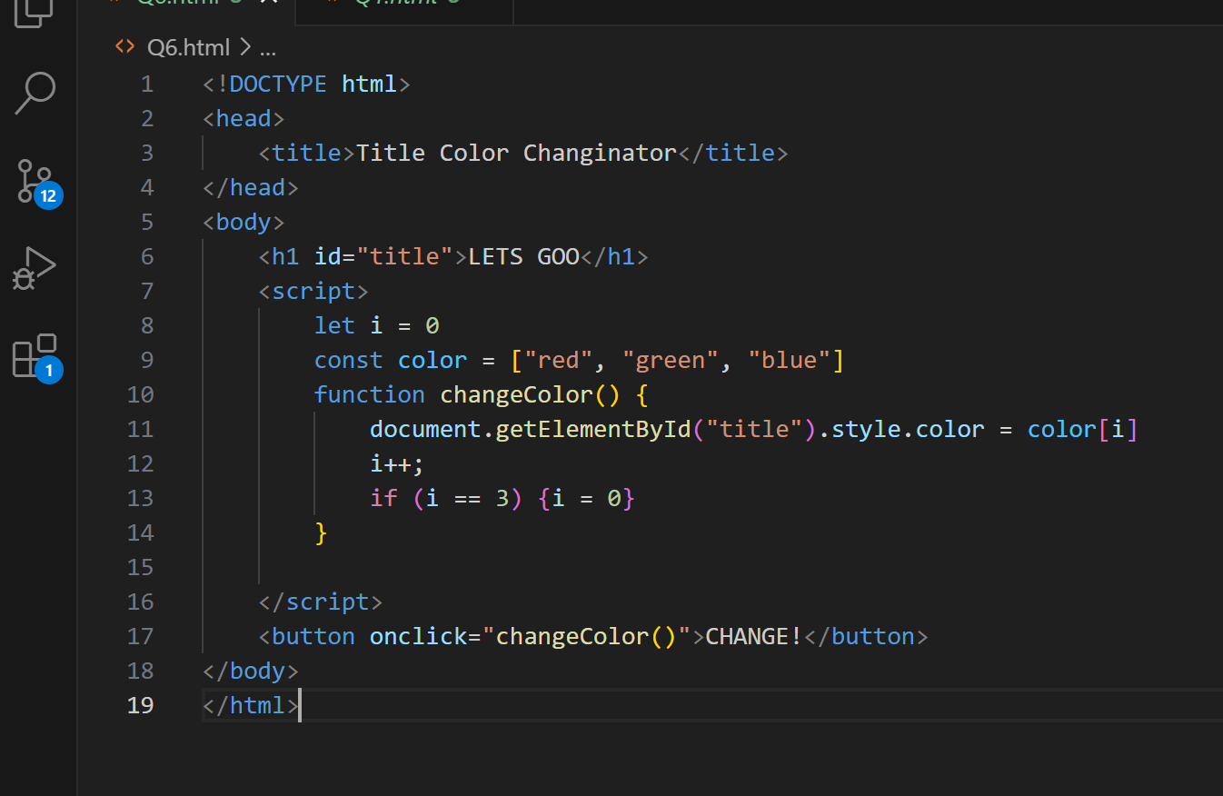

# Q7.

Code:

<!DOCTYPE html>

<head>

<title>Removinator</title>

</head>

<body>

<h1>Grocery List</h1>

<ul id="groceryList">

<!-- <li>Apple</li>

<li>Banana</li>

<li>Orange</li>

<li>Watermelon</li>

<li>Biscuit</li>

<li>Chips</li>

<li>Medications</li> -->

</ul>

<script>

const grocery = ["apple", "banana", "orange", "watermelon", "biscuits", "chips", "medications"]

for (let i = 0; i < grocery.length; i++) {

document.getElementById("groceryList").innerHTML += ("<li>" + grocery[i] + "</li>");

}

function popItem() {

grocery.pop();

document.getElementById("groceryList").innerHTML = '';

for (let i = 0; i < grocery.length; i++) {

document.getElementById("groceryList").innerHTML += ("<li>" + grocery[i] + "</li>");

}

}

</script>

<button onclick="popItem()">pop</button>

</body>

</html>

Screenshots: